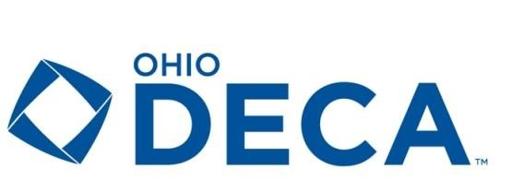
2026-27 Executive Council
District 1
Kelly Cooper, Defiance High School
kcooper@defianceschools.net

District 2
Cara Maxey, Penta Bowling Green High School
cmaxey@bgcs.k12.oh.us

District 3
Heidi Lisi, St. Mary’s Memorial High School
Heidi.Lisi@smriders.net

District 4
Eric Wagner, Northmont High School
ewagner@northmontschools.net

District 5
Trevor Ward, Great Oaks Harrison High School
wardt@greatoaks.com

District 6
Justin Servis, Great Oaks Anderson High School
servisj@greatoaks.com

District 7
Eric Wells, Olentangy High School
eric_wells@olentangy.k12.oh.us

District 8
Kelly Robinson, Groveport Madison High School
kRobinson@efcts.us

District 9
Dr. Tom Griffin, Maple Heights High School
thomas.griffin@mapleschools.com

District 10
Aja Tompot, Lake High School
tompotaja@lakelocal.org

District 11
Samantha Coldwell, Four Cities Compact
scoldwell@barbertonschools.org

District 12
Mike Goins, Western Brown High School
mike.goins@wbbroncos.com

District 13
Rebecca McCowan, Great Oaks Princeton High School
mccowanr@greatoaks.com

